Many Chinese Think Americans Lack Resolve to Prevail in Battle, Expert Says
2 Jan 2019 Stars and Stripes | By Seth Robson
Military.com
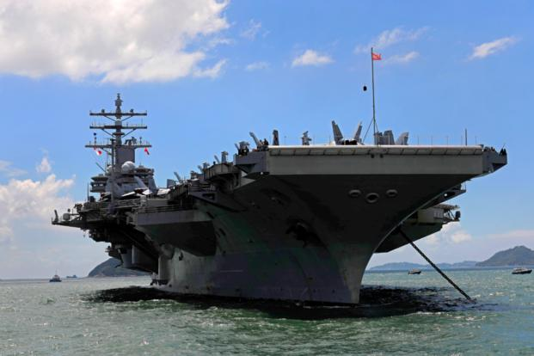
In this Monday, Oct. 2, 2017, file photo, the USS Ronald Reagan aircraft carrier arrives in Hong Kong. (AP Photo/Vincent Yu)
Too many in China think the United States will cut and run if war breaks out in the Far East, a U.S. defense expert warned Wednesday in response to threats by a Chinese war hawk.
"A far larger number of Chinese believe it than I think is healthy," said Brad Glosserman, a China expert and visiting professor at Tokyo's Tama University.
Glosserman was responding to comments by Chinese Rear Adm. Lou Yuan, who told an audience in Shenzhen last month that sinking a pair of U.S. aircraft carriers would settle issues of sovereignty in the South China Sea, according to the News Corp Australia network.
China has strengthened its grip on the disputed territory in recent years, moving military equipment onto artificial islands and harassing aircraft and ships passing through the area.
New anti-ship missiles could take out America's largest warships, Yuan -- deputy head of the Chinese Academy of Military Sciences -- said in his speech Dec. 20 at the Military Industry List summit.
"What the United States fears the most is taking casualties," he said, noting that 5,000 servicemembers would die on each sunken U.S. carrier.
"We'll see how frightened America is," he said, according to the Australian report.
The comments reflect a widespread belief that America lacks resolve to prevail on the battlefield, Glosserman said.
Too many Chinese think "Americans have gone soft … [they] no longer have an appetite for sacrifice and at the first sign of genuine trouble they will cut and run," he said.
The issues at play in the South China Sea are a core national interest for China; the U.S. sees them as abstractly important, Glosserman said.
Lack of democracy in China means the nation's tolerance for combat losses is likely higher than in the U.S., he added.
Yuan, who holds only an academic military rank and hasn't commanded Chinese forces, advocated exploiting America's military, financial system, workforce, electoral system and fear of adversaries, News Corp reported.
"Attack wherever the enemy is afraid of being hit," he said, "wherever the enemy is weak."
Yuan said last month that China should invade Taiwan if the U.S. Navy stopped there, according to comments published by the state-run Global Times newspaper.
"Achieving China's complete unity is a necessary requirement," he said. "The achievement of the past 40 years of reform and opening-up has given us the capability and confidence to safeguard our sovereignty.
"Those who are trying to stir up trouble in the South China Sea and Taiwan should be careful about their future," he added.
Remnant of the Light
Prophecy in the News

