A real nightmare before Christmas: San Jose Christmas event includes Satanic tree display
Dec 1, 2018 6:02 pm
Teri Webster, STAFF WRITER, TheBlaze.com
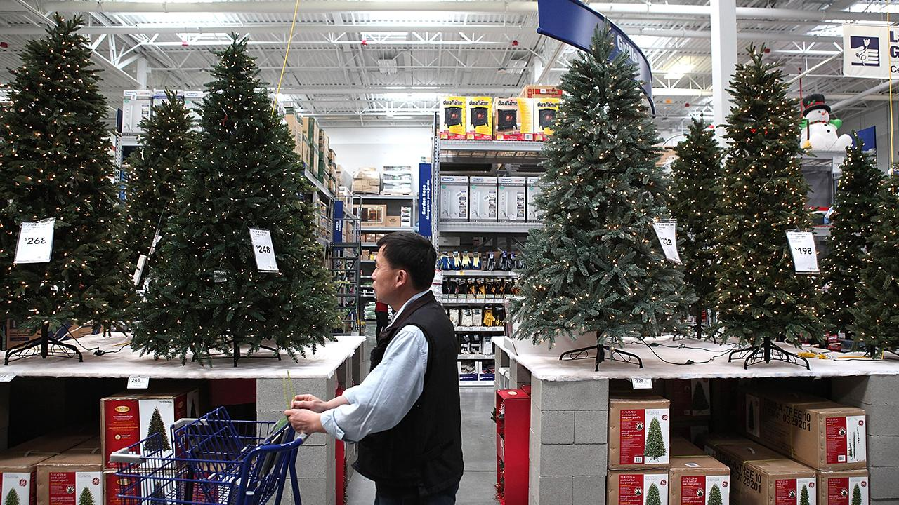
A shopper walks by a display of artificial Christmas trees at a retail store. (Photo by Justin Sullivan/Getty Images)
Thieves targeted a Satanic group’s so-called Christmas tree in San Jose, California, this week by stealing some of its occult-related ornaments.
What is this?
“The tree targeted was decorated with pentagrams and other demonic symbols, its decorations sponsored by a Bay Area Satanic organization,” KPIX-TV reported.
The tree is one of more than 500 on display at the annual Christmas in the Park event.
KPIX’s report included comments that support the Satanic group, but it offered no Christian rebuttal of the blasphemous display.
“Some may wonder why a Satanic group would have a decorated tree at a holiday display like Christmas in the Park, but not the organizers of the event or the people who set up the tree,” the report states.
If anyone’s still wondering, it’s because devil-worshipers’ “religion” typically inverts Christian symbols and mocks Jesus Christ. That’s why occultists use inverted crosses, which are seen in the TV station’s video footage of the tree.
The TV station refers to the Christmas tree event as “South Bay’s biggest holiday celebration.”
“Bay Area Satanist Simone Chavoor and her friend Tabitha spent Wednesday afternoon sprucing up the tree that was recently robbed,” the report states. “The group decorated the tree on Black Friday, complete with an elaborate goat head as a tree topper.”
And why would their tree be a target?
“It could be anything from kids, to people who don’t agree with our viewpoint to people who are actually in agreement with us and think that our ornaments are cool,” said Chavoor. She told the TV station she is a “member of a local Satanic Temple as well as the independent group Satanic Bay Area, which sponsored this tree’s decorations.”
Decorating a Christmas tree with occult symbols is just one of the public stunts staged by Satanists who worship “the father of all lies.”
Others include carting an 8-foot Baphomet goat statue around the nation and publicly displaying it under the guise of support for the First Amendment, billboards condemning corporal punishment of kids and after-school Satan clubs.
An organizer for the Christmas event said it’s not uncommon for ornaments to be stolen from the trees.
“It happens every year that one tree will get its ornaments stolen,” said Jason Minsky an organizer with Christmas in the Park. “We encourage people not to put ornaments on the trees that they think people will want to take. We encourage people to tie the ornaments to the tree so that they are harder to take.”
Like other occult-related agendas, the tree is apparently a way to foist occult beliefs into public platforms and then demand political correctness.
What are people saying?
The report does exactly that, stating:
“To some people, the close juxtaposition of Christian and Satanic symbols at a community Christmas event is no big deal.
‘It’s freedom of speech and religion,’ said San Jose resident Grant Talarico. ‘So as far as I’m concerned the tree is fine.’
Others said the Satanic tree could be offensive given the location.
‘I’m not Christian, but I’m sure some people would be offended because Christmas is a Christian holiday. And this seems like anti, since they have an upside down cross and everything,’ said Jag Jit of San Jose.”
All of this goes beyond removing the word “Christmas” and nativity scenes from schools as well as private businesses.
Now Christians are being asked to tolerate Christmas trees decorated with upside-down crosses and other devil-worshiper symbols.
News Report
Remnant of the Light
Prophecy in the News
Jeremiah Chapter 10
Idols and the Living ELOAH
1 Hear the Word which JAHWAH speaks to you, O house of Israel.
2 So says JAHWAH, Do not learn the way of the nations, and do not be terrified at the signs of the heavens; for the nations are terrified at them.
3 For the customs of the people are vain; for one cuts a tree out of the forest with the axe, the work of the hands of the workman.
4 They adorn it with silver and with gold; they fasten it with nails and hammers, so that it will not wobble.
5 They are like a rounded post, and they cannot speak. They must surely be lifted, because they cannot walk. Do not be afraid of them; for they cannot do evil nor good, for it is not in them.
6 There is none like You, O Jehovah; You are great, and Your name is great in might.
7 Who would not fear You, O King of nations? For fear belongs to You, because among all the wise men of the nations, and in all their kingdoms, there is none like You.
8 But they are all at once foolish and animal-like; the tree is an example of vanities.
9 Silver beaten into plates is brought from Tarshish, and gold from Uphaz, the work of the workman, and of the hands of the goldsmith. Violet and purple is their clothing; they are all the work of skillful ones.
10 But JAHWAH is the true ELAOH, He is the living ELOAH, and the everlasting King. At His wrath the earth shall tremble, and the nations shall not be able to stand His fury.
11 So you shall say to them, The gods who have not made the heavens and the earth, they shall perish from the earth and from under these heavens.
12 He has made the earth by His power; He has established the world by His wisdom, and has stretched out the heavens by His judgment.
13 When He utters His voice, there is a noise of many waters in the heavens. He causes the vapors to ascend from the ends of the earth; He makes lightnings with rain, and brings forth the wind out of His treasures.
14 Every man is stupid for lack of knowledge; every refiner is put to shame by the graven image; for his molten image is a lie, and no breath is in them.
15 They are vanity, the work of delusion; in the time of their judgment they shall perish.
16 The Portion of Jacob is not like them; for He is the Maker of all things; and Israel is the rod of His inheritance. Jehovah of Hosts is His name.
17 Gather up your bundle from the ground, you who live under the siege.
18 For so says Jehovah, Behold, I will sling out the people of the land at this time, and will distress them, so that they may find Me.
19 Woe to me for my breaking! My wound is grievous; but I said, Truly this is a malady, and I must bear it.
20 My tabernacle is ravaged, and all my cords are broken; My sons went away from me, and they are not. There is none to stretch out My tabernacle any more, and to set up My curtains.
21 For the pastors have become stupid, and have not sought JAHWAH, therefore they shall not be blessed, and all their flocks shall be scattered.
22 Behold, the noise of the rumor has come, and a great commotion out of the north country, to make the cities of Judah a desolation, a den of jackals.
23 O JAHWAH, I know that the way of man does not belong to man; it is not in man who walks to direct his steps.
24 O JAHWAH, correct me, but with judgment; not in Your anger, lest You bring me to nothing.
25 Pour out Your fury on the nations who do not know You, and on the families who do not call on Your name; for they have eaten up Jacob and have devoured him, and have destroyed him, and have made his dwelling desolate.

